Chemistry

This sample test paper has been prepared as part of the Pearson suite of resources for the Year 11, Unit 2, ATAR Chemistry Course prescribed by the Western Australian School Curriculum and Standards Authority.

Unit 2

Area of Study 8 Test:

Rates of chemical reactions

Time allowed

Reading time: 5 minutes Working time: 45 minutes

Materials required

An approved non-programmable calculator.

Chemistry Data Booklet. This may be downloaded by the SCSA website.

Structure of this paper

|  |  |  |  |  |  |
| --- | --- | --- | --- | --- | --- |
| Section | Number of questions available | Number of questions to be answered | Suggested working time (minutes) | Marks available | Percentage  of total test |
| Section 1: Multiple choice | 5 | 5 | 10 | 10 | 30 |
| Section 2:  Short answer | 4 | 4 | 40 | 24 | 70 |
| Total | | | 45 | 34 | 100 |

Section 1: Multiple choice 30% (10 marks)

This section has 5 questions. Answer all questions by circling the correct option. Marks will not be deducted for incorrect answers. No marks will be given if more than one answer is completed for any question.

Suggested working time: 8 minutes

_____________________________________________________________________________

1 Which one of the following is an endothermic process?

A the condensation of liquid water to ice

B the melting of chocolate

C CH4(g) + 2O2(g) → CO2(g) + 2H2O(g)

D the combustion of paper

2 Which one of the following statements is true according to the collision theory of reaction rates?

A Reaction rate is inversely proportional to concentration of reactants.

B The size of reactant particles has no influence on reaction rates.

C Reaction rate depends on the number of molecules exceeding the activation energy.

D As temperature increases the rate of reaction for an endothermic reaction increases while the rate of reaction for an exothermic reaction decreases.

3 Hydrogen gas can be produced from methane (CH4) in a process known as steam reforming. The equation for the reaction is shown below.

CH4(g) + H2O(g) → CO(g) + 3H2(g)

Which one of the following conditions will bring about the fastest rate of formation of hydrogen?

A high pressure of water vapour

B low pressure of methane gas

C high pressure of carbon monoxide gas

D low pressure of hydrogen gas

4 When a freshly cut piece of sodium metal is placed in water it immediately starts to react, often with the release of some sparks and flame. The best description of this reaction is an

A endothermic reaction with a large activation energy.

B endothermic reaction with a small activation energy.

C exothermic reaction with a large activation energy.

D exothermic reaction with a small activation energy.

5 Which one of the following best explains why not all collisions with energy above a reaction’s activation energy will result in formation of products?

A The molecules collide with incorrect orientation.

B The activated complex (transition state) is unstable.

C For some collisions above the activation energy the collisions are elastic (colliding molecules just bounce off each other).

D At higher temperature the particles are moving too fast for new bonds to form.

End of section 1

Section two: Short answer 70% (24 marks)

This section has 4 questions. Answer all questions. Write your answers in the space provided. When calculating numerical answers, show your working or reasoning clearly. Express numerical answers to the appropriate number of significant figures and include appropriate units where applicable.

Do not use abbreviations, such as ‘nr’ for ‘no reaction’, without first defining them.

Suggested working time: 37 minutes

_____________________________________________________________________________

Question 6 (4 marks)

In an experiment to determine the rate of reaction between hydrochloric acid and solid calcium carbonate, the mass of carbon dioxide lost from the reaction flask was measured every 20 seconds for a total of 120 seconds. The equation for the reaction is shown below.

CaCO3(s) + 2HCl → CaCl2(aq) + H2O(l) + CO2(g)

The following graph was produced.

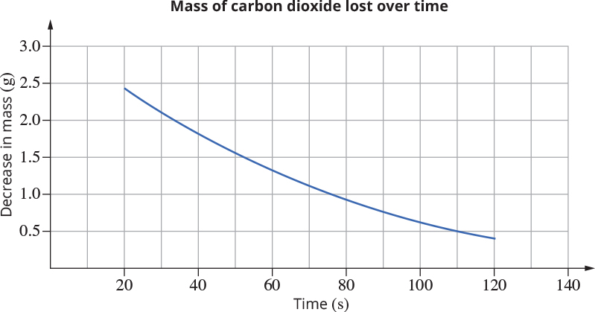

a Using collision theory, explain why the rate of loss of mass decreases over time. (3 marks)

___________________________________________________________________________

___________________________________________________________________________

___________________________________________________________________________

___________________________________________________________________________

___________________________________________________________________________

___________________________________________________________________________

b Suggest one other way the rate of this reaction may be measured. (1 mark)

___________________________________________________________________________

___________________________________________________________________________

___________________________________________________________________________

___________________________________________________________________________

Question 7 (10 marks)

Examine the energy profile diagram for a reaction to answer the questions that follow.

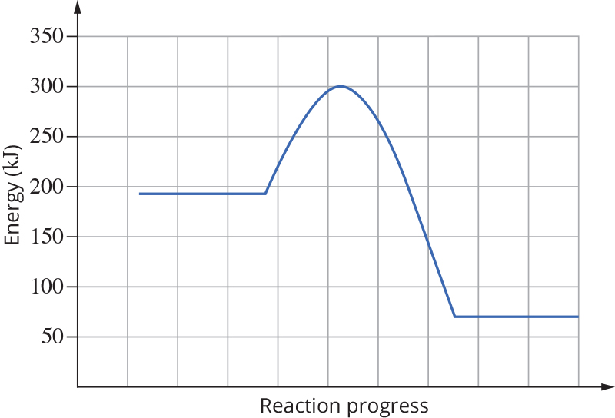

a On the diagram, label the enthalpy change, activated complex (transition state) and activation energy for the forward reaction. (3 marks)

b Give the value of the

i enthalpy change for the forward reaction. (1 mark)

______________________________________________________________________

ii activation energy for the reverse reaction. (1 mark)

______________________________________________________________________

c On the same set of axes above, draw a curve to show the energy profile diagram if the reaction takes place in the presence of a catalyst. (2 marks)

d State the effect of the catalyst on the rate of reaction and explain why it has the effect you have stated. (3 marks)

___________________________________________________________________________

___________________________________________________________________________

___________________________________________________________________________

___________________________________________________________________________

Question 8 (10 marks)

One step in the production of hydrochloric acid is the reaction of hydrogen gas with chlorine gas to make hydrogen chloride gas. The equation for the reaction is shown below.

H2(g) + Cl2(g) → 2HCl(g)

a State whether the rate of production of hydrogen chloride gas will be faster or slower when the pressures of the hydrogen and chlorine gases are high. Explain your answer using collision theory. (3 marks)

___________________________________________________________________________

___________________________________________________________________________

___________________________________________________________________________

___________________________________________________________________________

___________________________________________________________________________

b State the temperature conditions that will increase the rate of production of hydrogen chloride gas. Explain why the temperature conditions you have stated will increase the rate of production of hydrogen chloride gas. Support your answer with an appropriate diagram.

(7 marks)

____________________________________________________________________________

____________________________________________________________________________

____________________________________________________________________________

____________________________________________________________________________

____________________________________________________________________________

____________________________________________________________________________

____________________________________________________________________________

____________________________________________________________________________

|  |
| --- |
|  |

End of questions